Ryan Bermudez

Period 1

Mr. Remington

Jeroo Project: Follow the line

Goal:the goal is to use methods and loops to make sure the jeroo stays on the flower line without picking up the flowers

description:In this lab you need to make the jeroo follow the line of flowers and end facing the net

List Of Documents: FollowTheLineTemplate.jsc &FollowTheLine.jev

Before

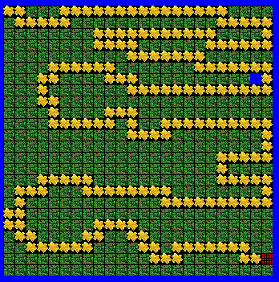

After

